The golden circles of leadership:
It is said that true leaders follow a different communication model:
They have a three shell information categorization : outermost shell : " WHAT " ,
middle shell : " HOW " ,
inner shell :: "WHY ".
unlike normal beings who communicate from what to how to why , they do so in reverse order.
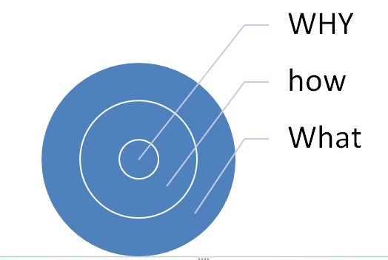

why we follow --- what to why :: because “what” is factual , objective , less analyisis demanding.......’how’ is bit complex , ‘why’ is very fuzzy.
like what we do : preparing to become ias , how : by hard work n all , but why :: that’s a tough question ( and all of us know that every time to think about it , we get a different answer ).
Why great leaders follow reverse order of communicating information::
well answer lies in biology , our brain ( if we have a top view ) have outermost section having neo-cortex , which is very good at processing information , while inner part of brain comprises limbic system , which processes emotions , drives our intuition and evolves conscience .
when we tell someone , why we want to do something , we actually get his deepest empathy ( like if we tell a shopkeeper that i want to change the system of rent-seeking by marketing inspector , hence i am channelizing my energies to become a part of system , and that's why i am preparing for IAS. )
Compare the impact of this with ( i want to become an IAS , hence i am doing hard work , so that i can change rent seeking behavior of marketing inspector )
Second one have less empathizing potential.
This principle is also very important in planning our lives :: if we first decide WHY , then go to HOW and then go to WHAT , we can definitely create better self-motivation potential . we will always retain a moral compass ( decided by WHY ) which will be critical in designing our path .
Apple in one of its strategic documents reveal that goal of company was not to make billion bucks , it didn't start with WHAT , it had a WHY at start and the answer of WHY : was to challenge the status quo . This end focused philosophy gives a higher degree of coherence to our actions and helps us in creating a meaningful life pattern .⁠⁠⁠⁠

